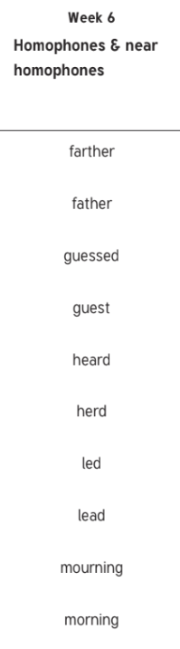

Attached

Awkward

Cautious

Committee

Communicate

Bought

Significant

Importance

Performance

Appearance