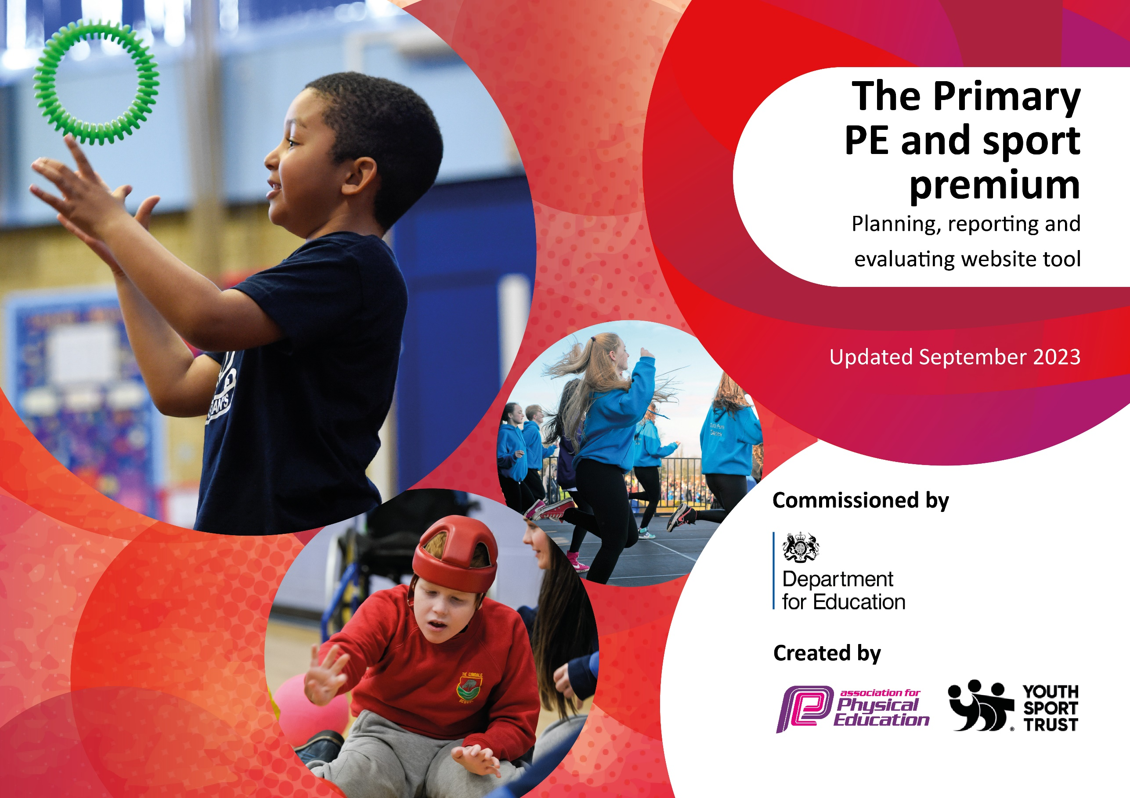

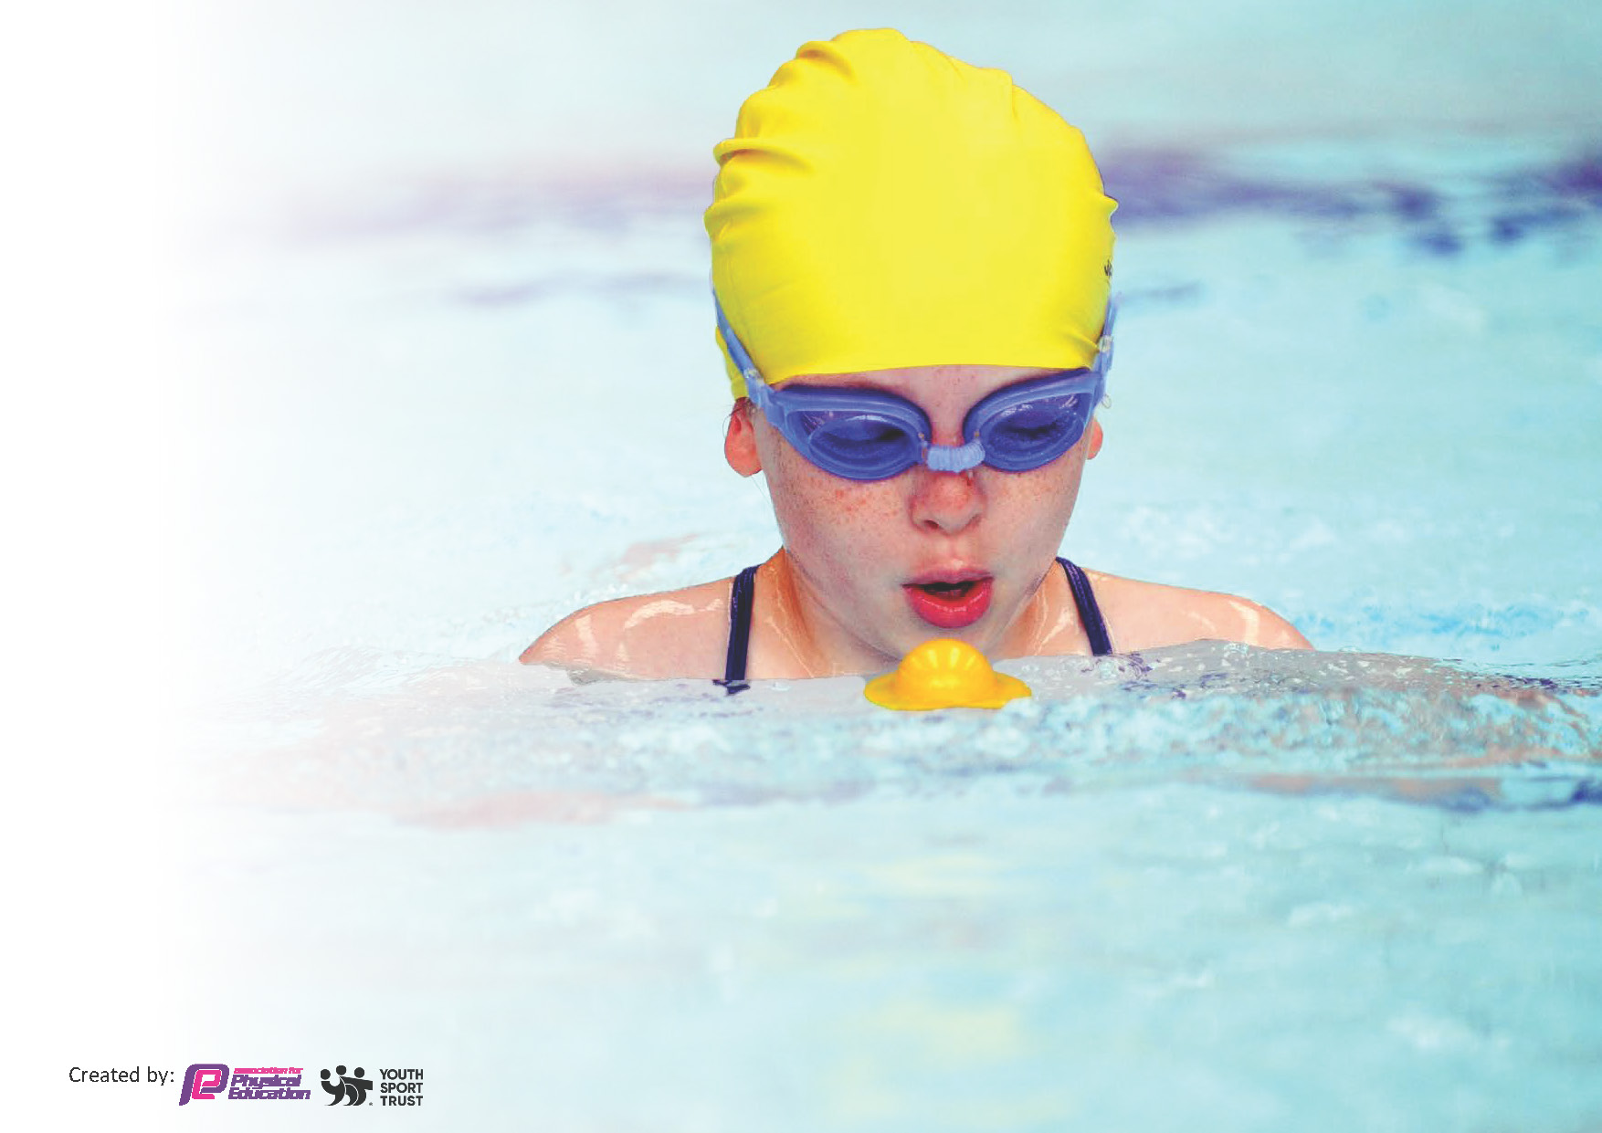
This template can be used for multiple purposes:
by:
- It enables schools to effectively plan their use of the Primary PE and sport premium
- It helps schools to meet the requirements (as set out in guidance) to publish information on their Primary PE and sport premium
- It will be an effective document to support Ofsted inspections enabling schools to evidence progress in Physical Education (PE) and evidence swimming attainment, which forms part of the PE National Curriculum. We would recommend schools consider
the Intent, Implementation and Impact of any spend, as examined within the Education Inspection Framework.

It is important that your grant is used effectively and based on school need.

Schools must use the funding to make additional and sustainable
improvements to the quality of the PE, School Sport and Physical Activity (PESSPA)
they offer. This means that you should use the Primary PE and sport premium to:

- Build capacity and capability within the school to ensure that improvements made now will benefit pupils joining the school in future years
- Develop or add to the PESSPA activities that your school already offers.

The Primary PE and sport premium should not be used to fund capital spend projects; the school’s core budget should fund these. Further detail on capital expenditure can be found in the updated Primary PE and sport premium guidance.

The Primary PE and sport premium guidance, outlines 5 key priorities that funding should be used towards. It is not

necessary that spending has to meet all the key priorities, you should select the priorities that you aim to use any funding towards.

Although completing this template is not a requirement for schools, schools are required to publish details of how they spend this funding. Schools must also outline what the impact this funding has had on pupils’ PE and sport participation and attainment and how any spending will be sustainable in the future. All funding must be spent by 31st July 2024.

The Department for Education has worked closely with the Association for Physical Education (afPE) and the Youth Sport Trust (YST) to develop this template and encourages schools to use it. This template is an effective way of meeting the reporting requirements of the Primary PE and sport premium.
Review of last year’s spend and key achievements (2022/2023)

We recommend you start by reflecting on the impact of current provision and reviewing your previous spend.

Activity/Action | Impact | Comments
This should be completed as a review. It could include reflections on the impact of spend across a range of the 5 KPIs.  - Funding used to allow SSP Sports Coaches to support morning activities for 3 days per week with the aim of engaging more and different children in regular lunch activity. We were also able to have a member of the team support us every week on a Tuesday – she is invaluable! | This section should include both measurable (data) and anecdotal impact.  For example , as a result of the actions are more children now active / how many / what % increase? It could also include notes from staff about changes in attitudes / engagement etc.  - As a result of this project , we were able to increase activity across the school by 20%. Jasmine led additional activities every Tuesday as well as the clubs we could offer. | This section is open to interpretation but include comments on what helped to make this successful or barriers to success. Partnerships/ organisations you worked with.  - Parents were pleased with the variety of clubs on offer and the children really enjoyed trying out new things.

Key priorities and Planning
This planning template will allow schools to accurately plan their spending.

Action – what are you planning to do | Who does this action impact? | Key indicator to meet | Impacts and how sustainability will be achieved? | Cost linked to the action
SSP Basic Membership Model (see attached)  To impact on KS 1 and 2 students and staff / including working with targeted cohorts and the least active within the school population.  - SSP Healthy Lifestyle assembly to raise whole school awareness of the importance of physical activity | - Staff as a CPD opportunity and students who engage with the assembly content | - Key Indicator 1 – Engagement of all pupils in regular physical activity | - All staff attended 3.9.23 Follow up Q and A by class teachers on content , production of tasks and slides available to schools | SSP Basic Membership £2000 which allows access to all listed (see attached)

.2. SSP delivery of 6 week Fit4Action health intervention scheme to a selected class  3.SSP Active Kids/ Character / Active Maths and Multi Skills Festivals  4. SSP Conference attendance including sessions from Teach Active and an Introduction to Physical Literacy  5.SSP termly staff inset sessions in school. Schools select the topic needed.  6.SSP Bespoke training session for Mid-day Assistants  7.Engage with Team teaching opportunities through SSP projects (Flying Start , Fit4Action and PALs)  8.Distribution of SSP termly newsletter to raise awareness and profile across the wider school community  9.Access to SSP CPD central training programme and courses  10.Access to the SSP full calendar of events, festivals , leagues and competitions  11.SSP PALs training for Year 5/6 and Year 2 mini PALs. Training of students to support peers and engage less active students in physical activity . Access to SSP Sports Leaders training.  12.Engaging a range of students in SSP performance based opportunities such as Dance Festival, Performance Festival , Cheer leading , Virtual Dance Events | - Targeted class of students and teaching and support staff as a CPD opportunity  - Identified students to benefit from attending intervention festivals all designed to inspire through a positive experience of physical activity  - PE Subject Leads , Maths and English Leads , teaching and support staff  - All staff in school  6.Mid-day Assistants and lunch support staff  7.Primary Teaching and Support staff  8. The whole school community including families and parents  9.Primary teaching and support staff  10.Students across the selected to attend the most appropriate events / staff gaining knowledge and ideas  11. Students receiving training and those benefitting from increased opportunities at lunch and break.  12.Students and staff attending events | .2. Key Indicator 1 – Engagement of all pupils in regular physical activity  3. Key Indicator 1 – Engagement of all pupils in regular physical activity  4. 1. Key Indicator 1 – Engagement of all pupils in regular physical activity  5. Key Indicator 2 – the profile of PESSPA being raised across the school and Key Indicator 3 – Increased confidence , knowledge and skills of all staff  - Key Indicator 2 – the profile of PESSPA being raised across the school and Key Indicator 3 – Increased confidence , knowledge and skills of all staff  - Key Indicator 2 – the profile of PESSPA being raised across the school and Key Indicator 3 – Increased confidence , knowledge and skills of all staff  - Key Indicator 2 – the profile of PESSPA being raised across the school  - Key Indicator 2 – the profile of PESSPA being raised across the school and Key Indicator 3 – Increased confidence , knowledge and skills of all staff  - Key Indicator 4 – Broader experience of a range of sports and activities offered to all pupils and Key Indicator 5 – Increased participation in competitive sport  11 Key Indicator 4 – Broader experience of a range of sports and activities offered to all pupils  12. Key Indicator 4 – Broader experience of a range of sports and activities offered to all pupils | 2.Profile of students and tracking of attendance in physical activity. School staff use of resources and content  3.Profile of students and tracking of attendance in physical activity. School staff accessing new ideas and concepts to take back to school.  4.Audit of cross-curricular activity pre and post training. Staff records of attendance. Measure use of resources and approach.  5.Details of staff audit , topics covered , track quality of delivery and levels of confidence.  6.Levels of lunchtime activities , tracking number of incidents and levels of confidence in staff  7.Levels of confidence , access to resources and knowledge remaining with teaching staff  - Longer term support and engagement from stakeholders regarding the importance of PESSPA  9.Attendance records,course details, certificates if required and continued monitoring of delivery.  10. Records of events entered and participation levels of children attending / longer term impact on access to PESSPA  11.Number of children active at break and lunch , and participating in clubs. Retain an infrastructure for PALs and Sports Leaders within the school.  12.Tracking of students involved and levels of activity

Key achievements 2023-2024
This template will be completed at the end of the academic year and will showcase the key achievements schools have made with their Primary PE and sport premium spending.

Activity/Action | Impact | Comments
Possible examples:  - Team teaching for all staff in areas of PE where they had the least confidence – 3 sessions led by SSP staff  - Through the SSP calendar of events we were able to provide an opportunity for every student to attend an event and represent the school at least once. Some multiple times. | - Staff received personalised support and the quality of lessons improved – staff knew where to go for support too.  - An opportunity for the school to celebrate all students. Increased sense of belonging and raised profile of being active. The addition of leadership has really supported some of our pupils with their development. | - This approach worked well in areas such as Gym and Dance. These are the areas identified by the majority of staff.  - This will remain a key aim for our school in future years

Swimming Data
Meeting National Curriculum requirements for swimming and water safety.
Priority should always be given to ensuring that pupils can perform safe self-rescue even if they do not fully meet the first two requirements of the National Curriculum programme of study

Question | Stats: | Further context  Relative to local challenges
What percentage of your current Year 6 cohort can swim competently, confidently and proficiently over a distance of at least 25 metres? | 70% | We have around 30% of children who can swim but are working towards their 25metres. These children are more confident with front crawl and back stroke and have not yet mastered breaststroke. They do not swim outside of school and have come a long way!
What percentage of your current Year 6 cohort can use a range of strokes effectively [for example, front crawl, backstroke, and breaststroke]? | 70% | Since regularly swimming at school, the children are exposed to a variety of swimming strokes to enhance their skills.

What percentage of your current Year 6 cohort are able to perform safe self-rescue in different water-based situations? | 100% | All children are taught how to stay safe in the water
If your schools swimming data is below national expectation, you can choose to use the Primary PE and sport premium to provide additional top-up sessions for those pupils that did not meet National Curriculum  requirements after the completion of core lessons. Have you done this? | Yes/No | Please note SSP TOP UP SWIMMING PROGRAMME DOES THIS COLLECTIVELY ACROSS THE AREA
Have you provided CPD to improve the knowledge and confidence of staff to be able to teach swimming and water safety? | Yes/No | We have dedicated swimming teachers who receive CPD to stay on top of their qualifications

Signed off by:

Head Teacher: | Mrs K Sansom
Subject Leader or the individual responsible for the Primary PE and sport premium: | Mrs J Fagence
Governor: | Mrs A Lloyd
Date: | 24.6.24

