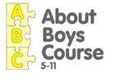 | 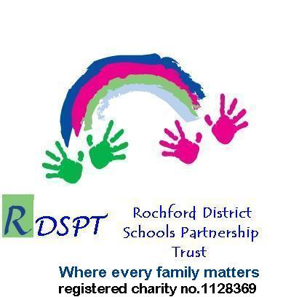

About Boys Course (ABC)

Down Hall Primary School, Brooklyn Drive, Rayleigh SS6 9LW
Tuesday 9.30am -11.30am starting 4 November 2014 for 4 weeks

This four-session course is targeted at mums with sons in years 1 and 2 and will give you:

- An understanding of your son’s development and behaviour;
- Practical ways to give him boundaries and discipline;
- More confidence in knowing how to get the best out of him.

Four Sessions:

Differences between boys and girls and boys' development

How to discipline boys and give them boundaries

Why boys do what they do and what motivates them?

Getting the best from boys at school

The course will be run by Maria Hill, Family Support Worker who has experience working with boys.

There are only 12 places
To book call Sonia Powell: 01702 545771 ext: 3226

