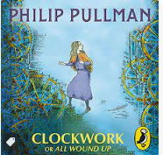 Predict what the book might be about. Infer from the clues on the front cover of the book!
Next, read the preface and answer these questions before submitting them to me 