Teachers : 16,500 per year

Head teachers : £30,000 per year

Materials :

Buildings- taken from Right Move

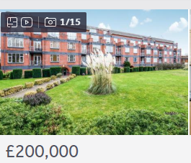

Desks

Pens

Pencils

