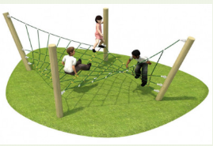

***Calling all UKS2! We have an exciting mission for you!***

If we were able to get a new adventure playground at Wyburns, what would you like it to look like? What things would you include? Have a look at what is available – using websites like <https://www.sovereignplayequipment.co.uk/> and <https://www.pentagonplay.co.uk/>. There are lots of websites out there for inspiration!

Your mission is to design a new adventure playground with a budget of £10,000. Think carefully about what you would add in there. How much it costs and whether all of the children could access it. How fun can you make it within the budget?

Your designs must be sent in to [homelearning@wyburns.org](mailto:homelearning@wyburns.org) by 10th July 2020

What if we were able to make part of your design a reality? How amazing would that be!?

Once your design wishes are in we can go to the next stage of our project!

Team Wyburns