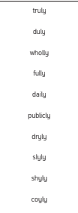
believe
bicycle
breath
breathe
build
adding
subtracting
multiple
tectonic
volcano

