Titanic Exhibition
At the Rayleigh Town Museum
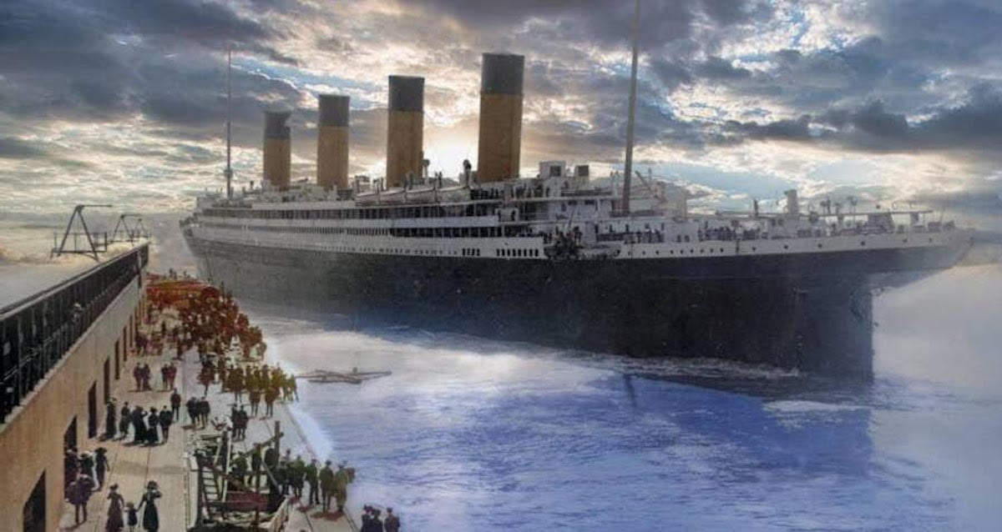
1st April – 26th April 2026

Usual opening times (10am – 4pm)
Wednesday, Friday and Saturday
Special opening times (11am – 3pm)

Sunday 5th
Monday 6th
Sunday 12th
Sunday 26th
Exhibition includes:
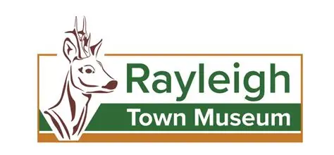
PAINTINGS │PRINTS │ BOOKS │ POSTCARDS │ EPHEMERA
Rayleigh Town Museum
1st Floor, 91 High Street, Rayleigh SS6 7EJ
www.rayleightownmuseum.org
Email: mikedavies@rayleightownmuseum.org Call: 01268 773535

