
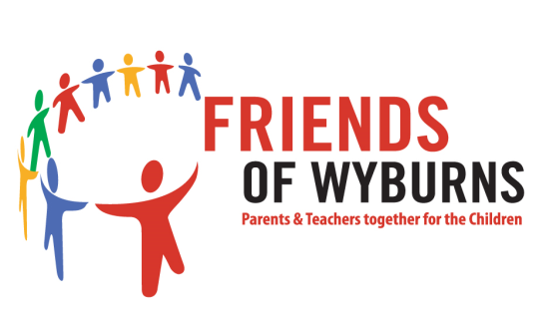

www.wyburns.org
Wyburns Primary School 2026 Estate Agents Form

Thank you for helping to support our Summer Fair by agreeing to have an Estate Agents Advertising board erected at your property.

Please complete the below form at your earliest convenience. This is required to ensure compliance with the General Data Protection Regulations (GDPR2018). Please note that this form will be forwarded to Gilbert & Rose Estates Agents and to the contractor carrying out the work.

-------------------------------------------------------------------------------------------------------------------------------------

Full Name:

Address:

Phone no:

Email address:

Do you have a fence/wall or would the sign need to be freestanding:

Signature: DATE:

Please contact friendsofwyburns@outlook.com for further information. Please send the completed form back via e-mail or to the following address:

Friends of Wyburns
Wyburns Primary School
Nevern Road
Rayleigh
Essex
SS6 7PE

Many thanks
Friends of Wyburns
On the 25th May 2018 the General Data Protection Regulation, known as GDPR, came into effect. GDPR imposes additional obligations on organisations and gives you extra rights around how your data is used. We want you to know that Friends of Wyburns respects the information that you give us before and during any event and that we take the security of your information seriously. We only ask for the minimum information possible. Information given to us is not forwarded onto anyone unless we have a prior permission. All records at the time are kept securely and are accessible by limited number of people. Once event has ended records are destroyed in a controlled way. We would like to keep you details on record for future events please let us know if you do not agree to this.

